Workout Buddy App

# Useful Links

* Prototype:
  + <https://xd.adobe.com/view/c02956d6-4b40-4cda-9a0d-fab2c3c3f74b/>
* Apple Human Interface Guidelines:
  + <https://developer.apple.com/ios/human-interface-guidelines/>

# Description

Workout Buddy is a lightweight workout app that is intended to be quick and easy to use to plan and track your workouts. The user can create workouts and schedule them for certain days of the week so you won’t have to keep track of when to do a workout.

# Screens not mocked

Before I get into the app here is a short list of what is not mocked and will need to be designed.

1. Login Screen
   1. The user will be able to log into the app with Email and Password **or** with Facebook
      1. A good example of this is “Spotify’s” login screen.
2. Account Screen:
   1. Includes:
      1. Logout Button
      2. User’s email (this will be their username)
      3. Anything else you might think that is useful
3. Statistics screen
   1. Haven’t really defined this yet but here is the idea:
      1. The screen will have a list of all exercises (not workouts) that the user can choose from.
      2. When the user chooses an exercise a screen pops up with a line-plot of their progress for that exercise over the last 3 months. I’m thinking a line plot like the image below but if you think something else makes more sense go for it. (line plots are easier to code though)

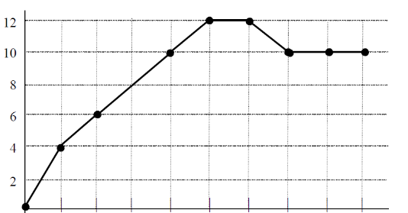

1. Help Screen
   1. This is really just text. I will be defining the terms used in the app; like what a “Workout” is vs. an “Exercise” along with anything else that might help the user. Let me know if you need copy for this.

# Main Navigation

## Tabbar Navigation

Rob's SSD:Users:RobertBarber:Desktop:Toolbar.pngThis app will be using a tabbar navigation scheme to navigate to the main screens of the app. All sub-navigation will be handled through buttons (ex. Add buttons or clicking on items)

# Main Screens

## Note:

Not all screens are accounted for in this document. Look in the “Screens” folder or the prototype link to see them. This is because some are re-used or the design can be reused from another screen.

## Dashboard

The main screen of the app. The user can scroll through their previously completed workout sessions and navigate to their workout schedule.

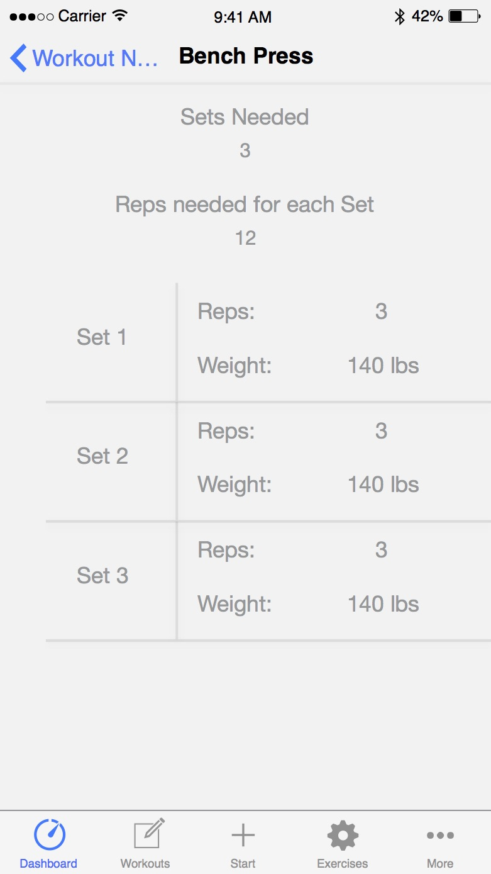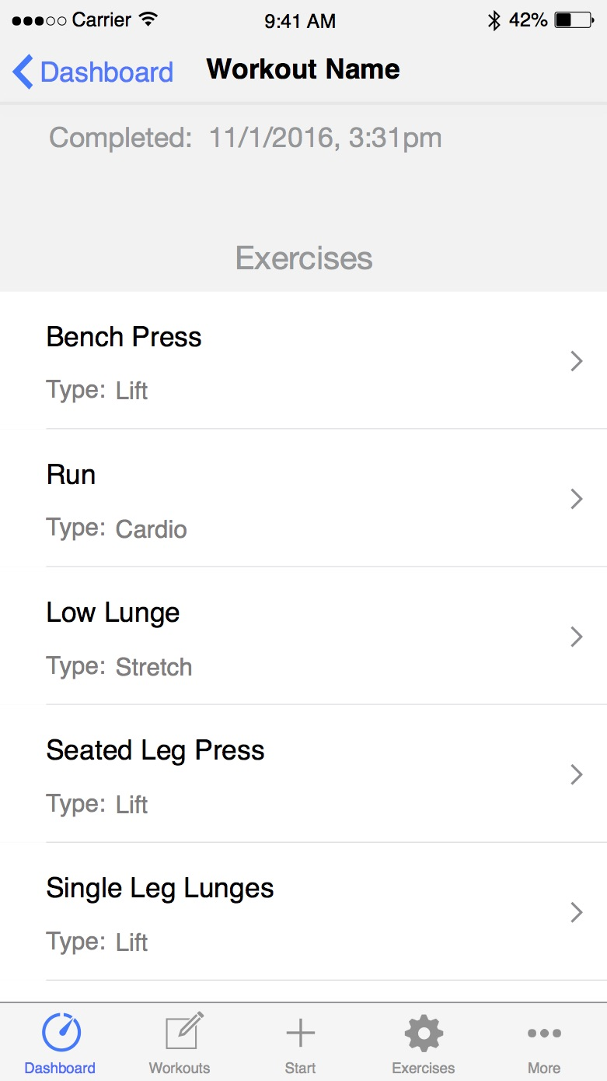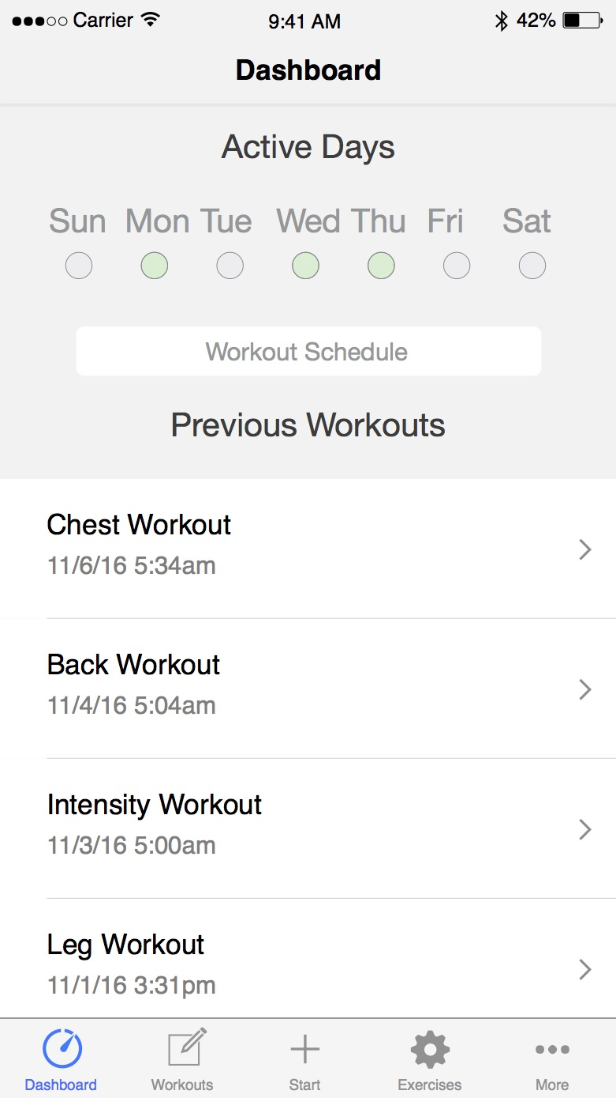

## Workouts

The “Workouts” screen is where the user will manage their workouts. A workout consists of Exercises that the user will perform.

## Exercises

Workouts: Exercise edit

Workouts: Detail

Workouts: Main

The “Exercises” screen is where the user will manage their exercises. Exercises consist of movements under these types: lifts, cardio and stretches. Users can set target metrics from this screen and can record the actual performed duration or sets while in a session.

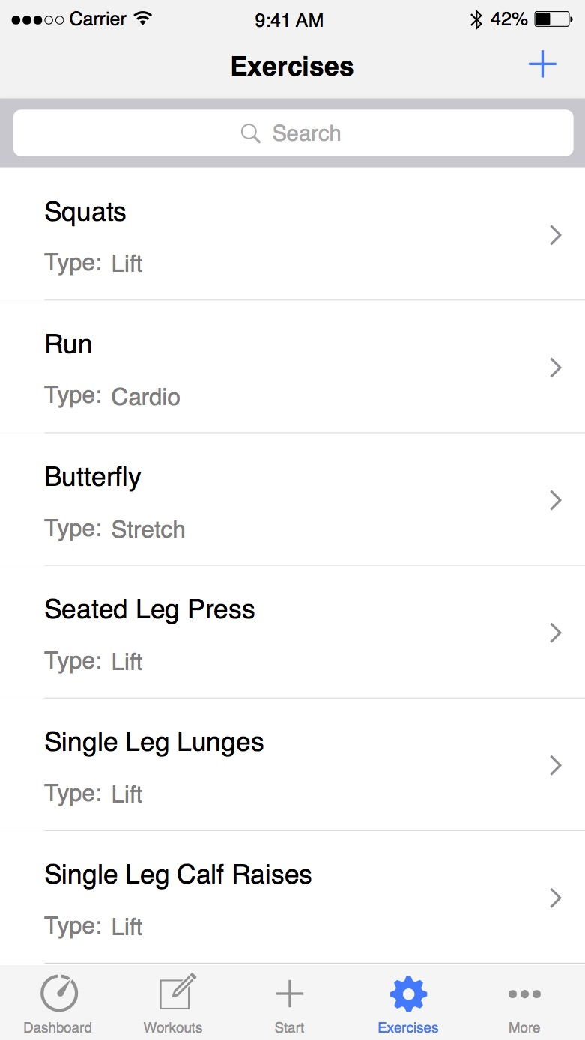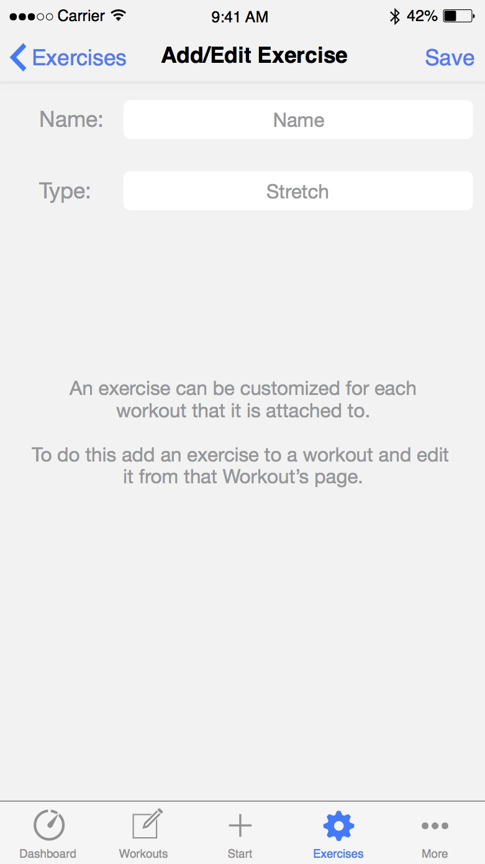

Exercises: Main

Add/Edit Exercise

## Start

The “Start” screen is actually the “In Session” workout that the user is currently performing. This refers to the center button in the tabbar navigation. It consists of 3 main screens.

The little stopwatch icon at the bottom of the screen to the right is meant to open a rest timer so the user knows how long to rest for. Right now this will actually be a stopwatch that counts up.

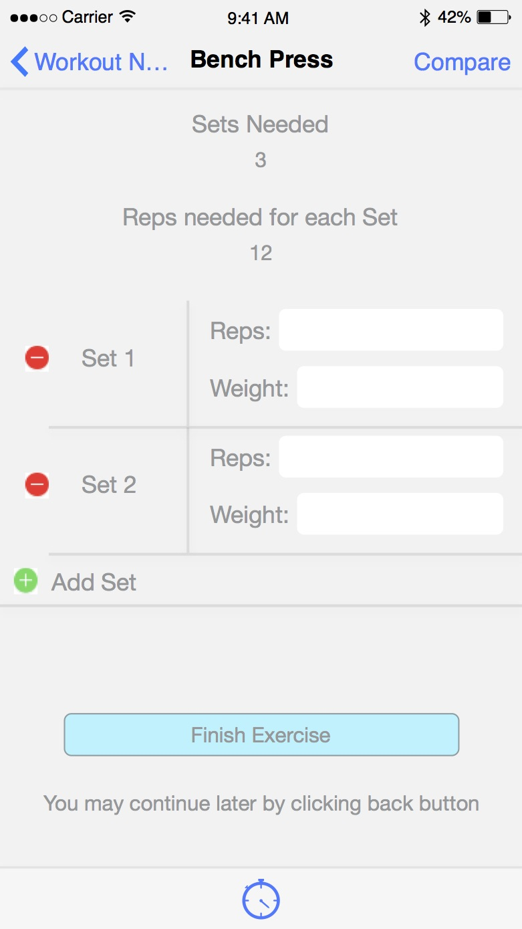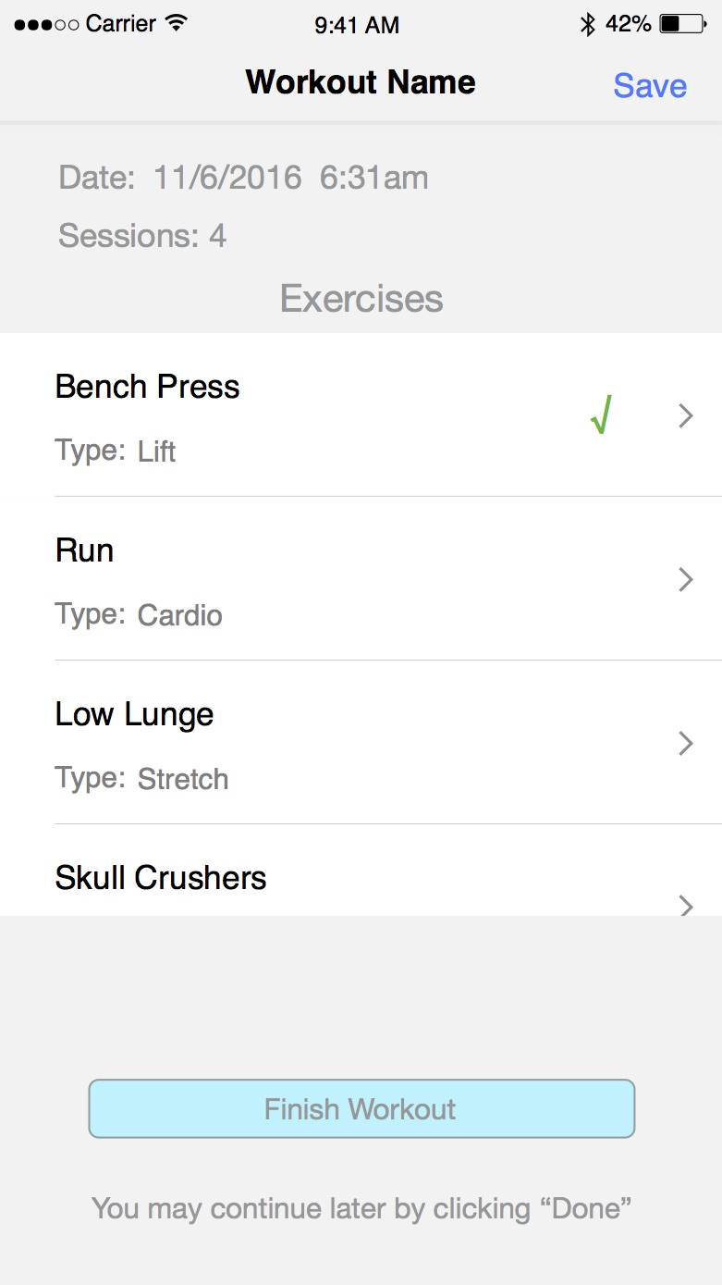

Start: Exercise View

Start: Main

## Schedule

The “Schedule” screen is where the user can plan their week out for workouts. The schedule repeats weekly and can have only one workout per day.

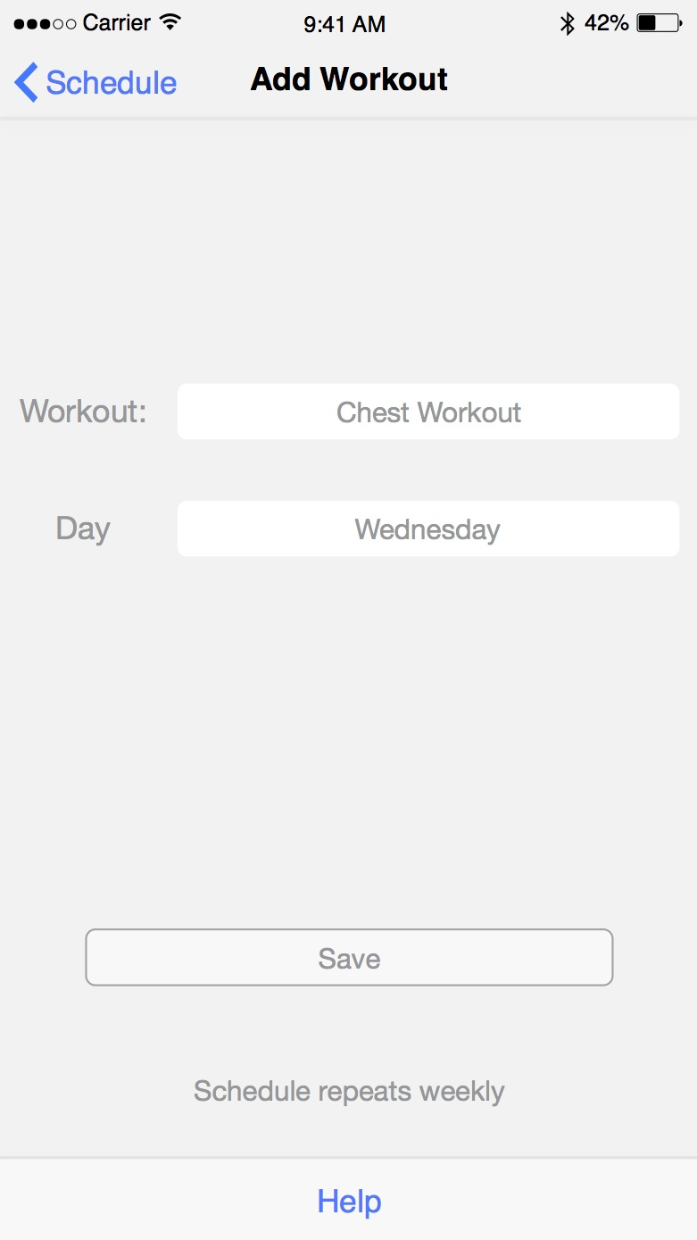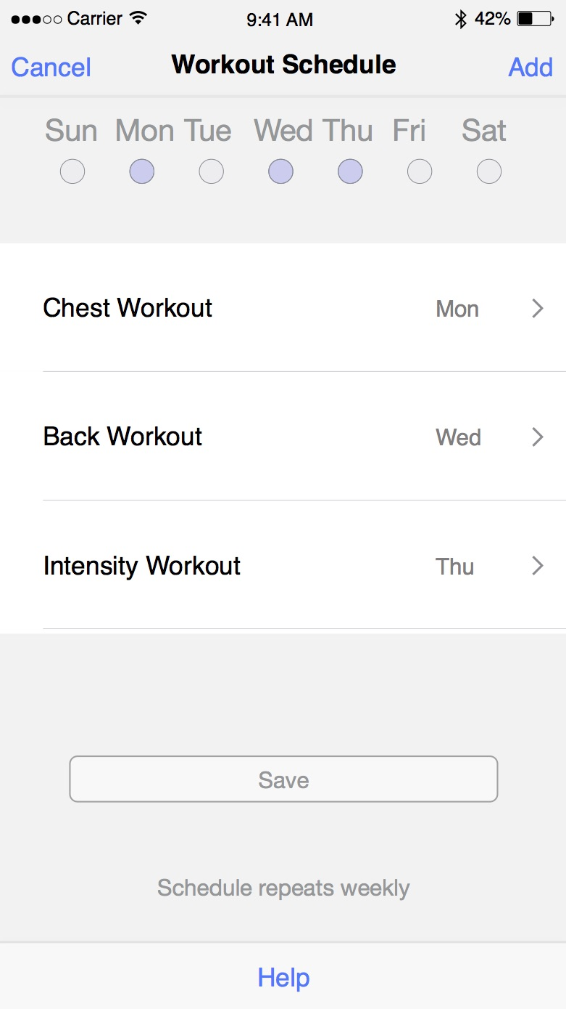

Schedule: Edit Workout

Schedule: Main

## More

Any other screen that can’t fit as an icon within the tabbar goes here. This is a list of names and icons representing the other screens for the user to navigate to.

Note: Only the “Schedule” screen has been mocked up for this.

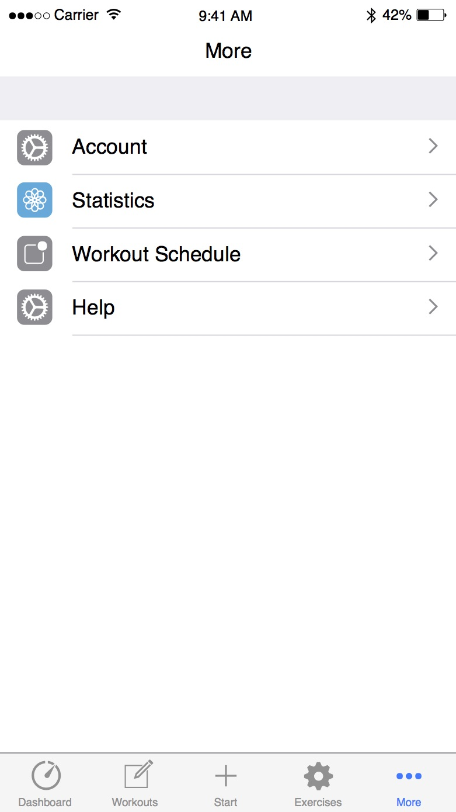

More: Main